Matthew Hoffman

CpE 403 – Advanced Embedded Systems

CC1350 Lab 3

# Task 1: Import and run an existing TX example with Code Composer Studio

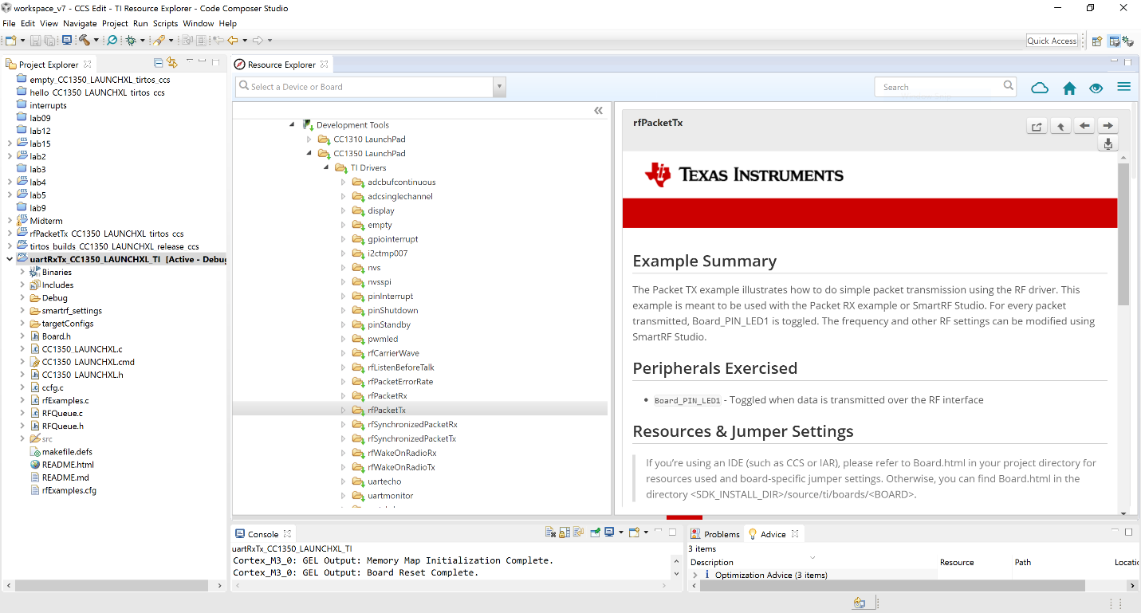

**Figure 1. Task 1.a Example Import**

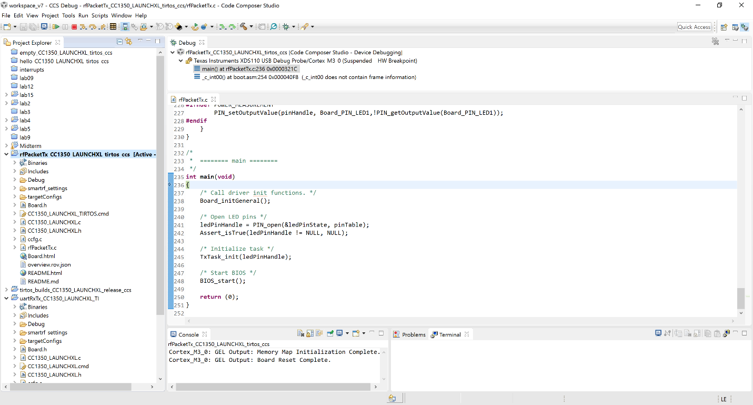

**Figure 2. Task 1.b Debug Example Project**

# Task 02: Importing and Modifying rfPacketRx

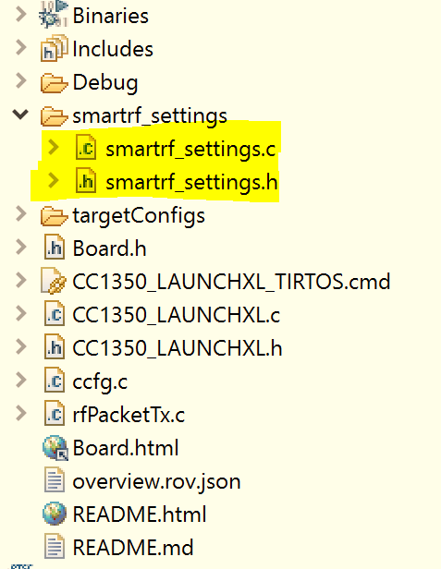

**Figure 3. Task 2.a Import Project**

# Task 3: Firmware TX -> Firmware RX

<https://youtu.be/F484V_uN4bo>

# Task 4: Single Node TX & RX

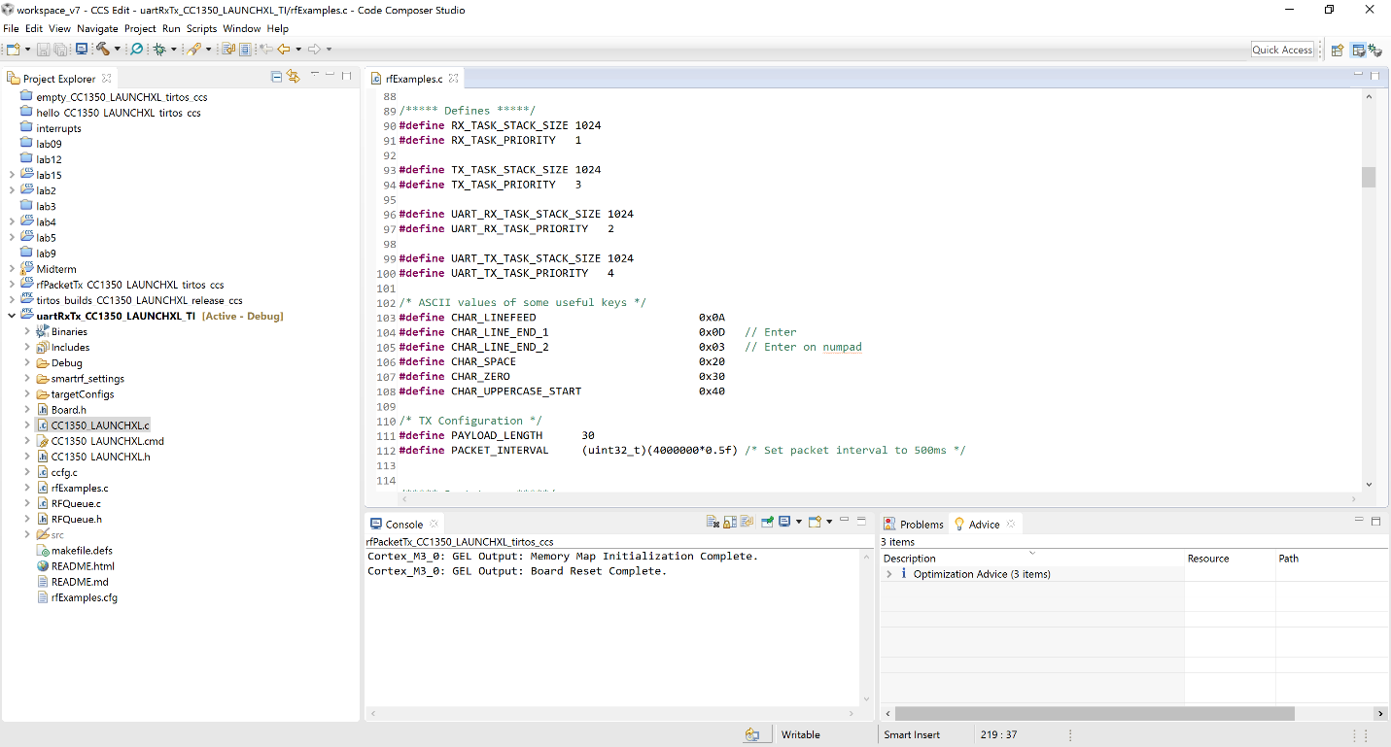

**Figure 4. Task 4.a Import and Build uartRxTx**

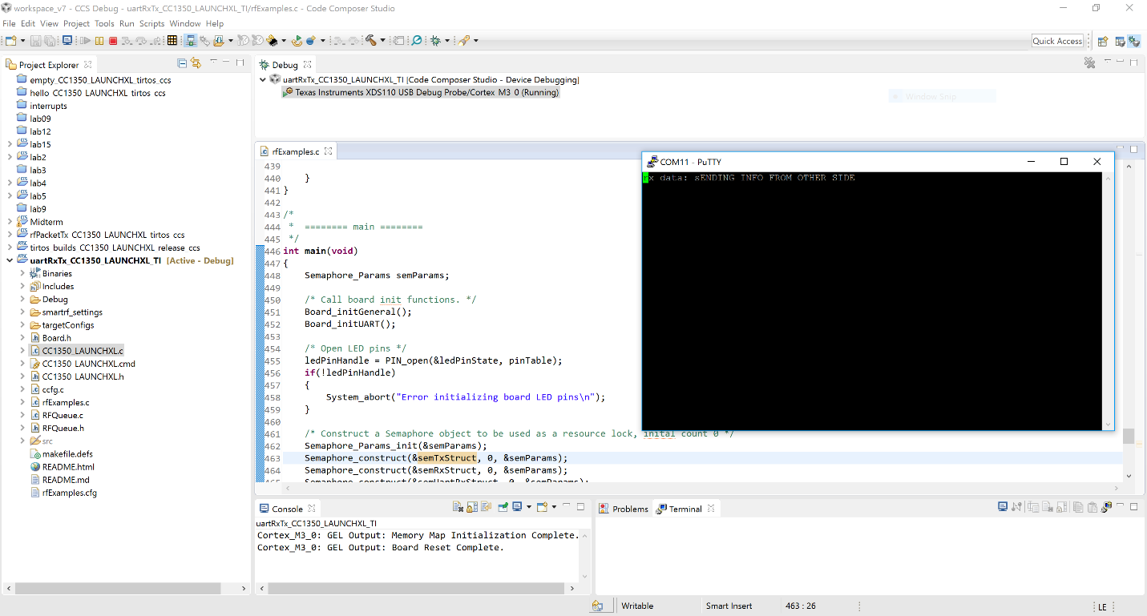

**Figure 5. Task 4.b Sending Data to Other CC1350**



**Figure 6. Task 4.c Rx Putty**